Responding to Non-Responsive Behavior:

Basic Practices and Systems

George Sugai

Center on Positive Behavioral Interventions and Supports
www.pbis.org
Center on Behavioral Education and Research
www.cber.org
University of Connecticut

March 7, 2009

Preventing & Responding to Problem Behavior: Overview of Best Practice

George Sugai

Why this overview?
The purpose of this overview is to assist school teams in their development and implementation of school-wide practices and systems for responding to norm violating problem behavior.

What is “discipline?”
“Discipline” is the collection of implemented steps, policies, or actions developed to support teaching and learning environments so the likelihood of student academic and social success is promoted, in particular,
- Increases in the likelihood of occurrences of socially appropriate behavior.
- Decreases in the likelihood of occurrences of problem or rule violating behavior.
- Decreases in the intensity, frequency, and duration of severe problem behavior.

To achieve these outcomes, the emphases are on
- Teaching and reinforcing context-appropriate social behaviors or skills.
- Removing antecedent factors that trigger occurrences of problem behavior.
- Adding antecedent factors that trigger occurrences of context appropriate social skills.
- Removing consequence factors that maintain (function) occurrences of problem behaviors.
- Adding consequence factors that maintain occurrences of context appropriate social behaviors.

What should be considered when developing and implementing SWPBS?
- Use continuous data collection to guide decision making
- Have measurable benchmarks or decision rules for determining when student behavior is occurring at acceptable rates or is unresponsive to intervention and a more intensive/specialized intervention should be considered.
- Establish school discipline as instrument for academic and behavior success
- Give priority to research-validated practices that can be arranged in a continuum of behavior support for all, some, and a few students.
- Emphasize an instructional, preventive approach to behavior management by teaching and encouraging prosocial behavior
- Conduct regular universal screening to determine students who are behaviorally successful and who might be at risk for behavior failure.
- Conduct regular assessments of the extent to which interventions and practices are implemented accurately, comprehensively, durably, and relevantly.
- Coordinate implementation efforts with school-wide leadership team

What are the MOST IMPORTANT things to remember when developing and implementing a continuum of procedures for responding to rule violations?
- Behaviors do not occur in a vacuum; they are more likely to be triggered by predictable antecedent events and maintained by predictable consequence events.
- Punishment strategies should never cause pain or humiliation, or put individual at risk of injury.
- Punishment is defined as a contingent consequence event that is associated with a decreased likelihood of a behavior occurring in the future.
- Punishment works best if used in environments where students experience high rates of academic and social behavior success, and high rates of positive adult attention. Punishment by itself is insufficient.
- SWPBS discipline systems (primary prevention/intervention) work for most students, and function as a “screening tool” for students who need more and different specialized and individualized support (secondary/tertiary prevention/intervention).
- Students who require secondary/tertiary prevention/intervention PBS must
  - Be taught and encouraged to use more socially appropriate alternative behaviors that “work” as effectively, efficiently, and relevantly as problem behavior….not more punishment for problem behavior.
  - Experience more frequent, more powerful, and more immediate positive acknowledgement for displays of appropriate behavior….not less.

Recommended Behavior Management Action for Responding to and Decreasing Likelihood of Norm Violating Problem Behavior
WHAT | ACTION
- Displays of expected behavior | - Look continuously for displays of expected behavior  - Label display of expected behavior (rule)  - Provide context appropriate and relevant positive reinforcement
- Prompts for desired behavior | - Provide effective signal, reminder, hint where and before problem behavior likely  - Label display of expected behavior (rule)
- Minor, not interfering problem behavior | - If possible, remove attention  - Wait for display of expected behavior and provide positive reinforcement.  - When problem behavior ends, prompt expected behavior  - Provide positive reinforcement for other-student displays of desired behavior  - Provide minor aversive consequence immediately following the problem behavior
- Minor, interfering problem behavior | - Signal error or problem behavior observed  - Remind/ask student for expected behavior  - Ask student to display/practice expected behavior  - Provide immediate and effective positive reinforcement after displays of desired behavior  - 1. and 2.
- Repeated minor problem behavior | - Identify context/setting/condition when problem behavior most likely to occur.  - Conduct functional assessment  - Develop antecedent and consequence actions based on predictable factors that trigger (antecedent) and maintain (consequence) problem and expected behavior  - 1. and 2.
- Classroom managed major | - Develop precorrection plan  - Teach/practice desired behavior  - Conduct FBA  - 1. and 2.
- Office managed major | - Follow school and district disciplinary procedures  - 1. and 2.

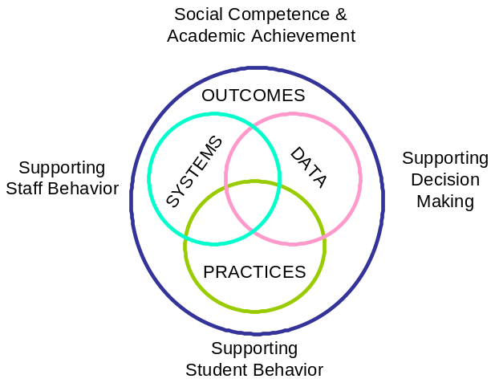 | 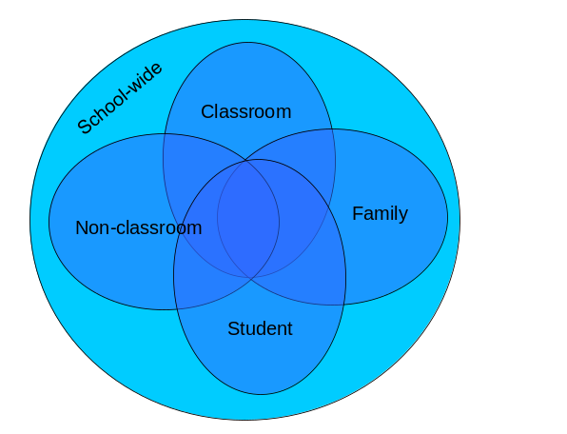

Behavioral Interventions and Practices
School-Wide | - Leadership team  - Common behavior purpose & approach to discipline  - Clear set of positive expectations & behaviors  - Procedures for teaching expected behavior school-wide & classroom-wide  - Continuum of procedures for encouraging expected behavior  - Continuum of procedures for discouraging inappropriate behavior  - Procedures for on-going data-based monitoring & evaluation
Classroom-Wide | - All school-wide above.  - Maximum structure & predictability (e.g., routines, environment)  - Positively stated expectations posted, taught, reviewed, prompted, & supervised  - Maximum engagement through high rates of opportunities to respond, delivery of evidence-based instructional curriculum & practices  - Continuum of strategies to acknowledge displays of appropriate behavior , including contingent & specific praise, group contingencies, behavior contracts, token economies  - Continuum of strategies for responding to inappropriate behavior, including specific, contingent, brief corrections for academic and social behavior errors, differential reinforcement of other behavior, planned ignoring, response cost, and time out.
Non-Classroom Settings | - Positive expectations & routines taught & encouraged/acknowledged  - Active supervision by all staff, emphasizing scanning, moving, & interacting  - Precorrections, prompts, & reminders  - Positive reinforcement
Individual Student | - Behavioral competence at school & district levels  - Function-based behavior support planning  - Team- & data-based decision making  - Comprehensive person-centered planning & wraparound processes  - Targeted social skills & self-management instruction  - Individualized instructional & curricular accommodations
Family Engagement | - Continuum of positive behavior support for all families  - Frequent, regular, & positive contacts, communications, & acknowledgements  - Formal & active participation & involvement as equal partners  - Access to system of integrated school & community resources

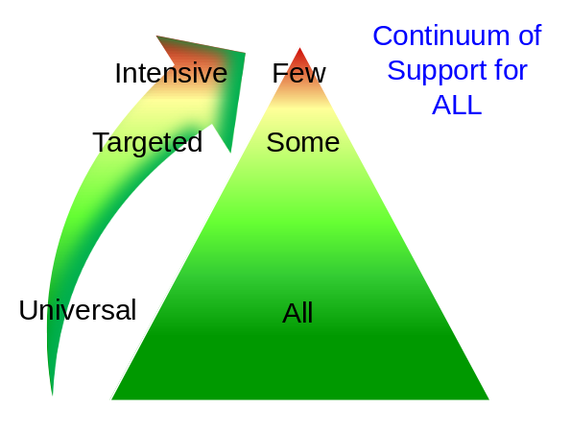 | 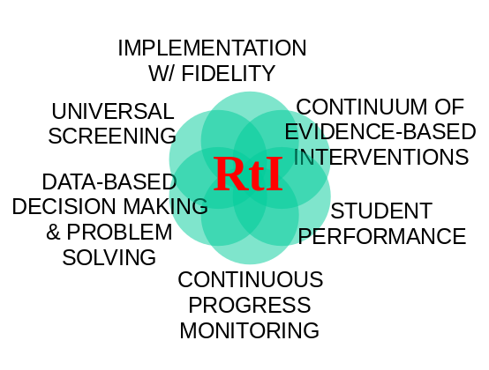
CLASSROOM MANAGEMENT: THE BASICS

Classroom Management Practice | Description
- Minimize crowding and distraction | - Design environment to elicit appropriate behavior:  - Arrange furniture to allow easy traffic flow.  - Ensure adequate supervision of all areas.  - Designate staff & student areas.  - Seating arrangements (classrooms, cafeteria, etc.)
- Maximize structure & predictability | - Teacher routines: volunteers, communications, movement, planning, grading, etc.  - Student routines: personal needs, transitions, working in groups, independent work, instruction, getting materials, homework, etc.
- State, teach, review & reinforce positively stated expectations | - Establish behavioral expectations/rules.  - Teach rules in context of routines.  - Prompt or remind students of rule prior to entering natural context.  - Monitor students’ behavior in natural context & provide specific feedback.  - Evaluate effect of instruction - review data, make decisions, & follow up.
- Provide more acknowledgements for appropriate than inappropriate behavior | - Maintain at least 4 to 1  - Interact positively once every 5 minutes  - Follow correction for violation of behavior expectations with positive reinforcement for rule following
- Maximize varied opportunities to respond | - Vary individual v. group responding  - Vary response type  - Oral, written, gestural  - Increase participatory instruction  - Questioning, materials
- Maximize Active Engagement | - Vary format  - Written, choral, gestures  - Specify observable engagements  - Link engagement with outcome objectives
- Actively & Continuously Supervise | - Move  - Scan  - Interact  - Remind/precorrect  - Positively acknowledge
- Respond to Inappropriate Behavior Quickly, Positively, & Directly | - Respond efficiently  - Attend to students who are displaying appropriate behavior  - Follow school procedures for major problem behaviors objectively & anticipate next occurrence
- Establish Multiple Strategies for Acknowledging Appropriate Behavior | - Social, tangible, activity, etc.  - Frequent v. infrequent  - Predictably v. unpredictably  - Immediate v. delayed
- Generally Provide Specific Feedback for Errors & Corrects | - Provide contingently  - Always indicate correct behaviors  - Link to context

Classroom Management Self-Assessment
Teacher__________________________ Rater_______________________ |  |  | Date___________
Instructional Activity |  |  | Time Start_______  Time End _______
Tally each Positive Student Contacts | Total # | Tally each Negative Student Contacts |  | Total #
Ratio of Positives to Negatives: _____ to 1
Classroom Management Practice |  |  |  | Rating
- I have arranged my classroom to minimize crowding and distraction |  |  |  | Yes No
- I have maximized structure and predictability in my classroom (e.g., explicit classroom routines, specific directions, etc.). |  |  |  | Yes No
- I have posted, taught, reviewed, and reinforced 3-5 positively stated expectations (or rules). |  |  |  | Yes No
- I provided more frequent acknowledgement for appropriate behaviors than inappropriate behaviors (See top of page). |  |  |  | Yes No
- I provided each student with multiple opportunities to respond and participate during instruction. |  |  |  | Yes No
- My instruction actively engaged students in observable ways (e.g., writing, verbalizing) |  |  |  | Yes No
- I actively supervised my classroom (e.g., moving, scanning) during instruction. |  |  |  | Yes No
- I ignored or provided quick, direct, explicit reprimands/redirections in response to inappropriate behavior. |  |  |  | Yes No
- I have multiple strategies/systems in place to acknowledge appropriate behavior (e.g., class point systems, praise, etc.). |  |  |  | Yes No
- In general, I have provided specific feedback in response to social and academic behavior errors and correct responses. |  |  |  | Yes No
Overall classroom management score:  10-8 “yes” = “Super” 7-5 “yes” = “So-So” <5 “yes” = “Improvement Needed” |  |  |  | # Yes____

Supervision Self-Assessment

Name______________________________ |  | Date_____________
Setting □ Hallway □ Entrance □ Cafeteria  □ Playground □ Other_______________________ |  | Time Start_________  Time End _________
Tally each Positive Student Contacts | Total # | Ratio of Positives to Negatives: _____: 1
Tally each Negative Student Contacts | Total # | Ratio of Positives to Negatives: _____: 1

- Did I have at least 4 positive for 1 negative student contacts? | Yes No
- Did I move throughout the area I was supervising? | Yes No
- Did I frequently scan the area I was supervising? | Yes No
- Did I positively interact with most of the students in the area? | Yes No
- Did I handle most minor violations of behavior expectations quickly and quietly? | Yes No
- Did I follow school procedures for handling major violations of behavior expectations? | Yes No
- Do I know our school-wide behavior expectations (positively stated rules)? | Yes No
- Did I positively acknowledge at least 5 different students for displaying our school-wide behavior expectations | Yes No
Overall active supervision score:  7-8 “yes” = “Super Supervision”  5-6 “yes” = “So-So Supervision”  <5 “yes” = “Improvement Needed” | # Yes_____

Developing a School-wide Continuum of Positive Behavior Support
The development of a SW continuum of requires a careful consideration of local context (features and data), desired outcomes (data, priority needs, etc.), evidence-based practices, and systems capacities and supports.
To enhance efficiency and relevance, the following steps for selecting practices within a school-wide continuum of positive behavior supports should be considered:
Steps for Selecting Practices within a School-Wide Continuum of Positive Behavior Support
Step 1: Identify what practices (e.g., interventions, programs, strategies) are available at each prevention tier. (See Practices Evaluation Chart)
Step 2: Evaluate each practice against the following evaluation criteria
- Evidence-based – Does experimental research evidence exist to support the selection and use of a practice to achieve desired outcome?
- Outcome Data – Are relevant data collected to measure effectiveness?
- Non-Responder Decision Rule – Are data-based rules available and used to modify intervention for students who do not respond to practice?
- Implementation Fidelity – Are data collected to assess and improve accuracy of practice implementation?
- Effectiveness – Have data demonstrated that practice is effective in achieving desired outcomes?
Step 3: Based on the above results, decide whether to (a) eliminate or discontinue, (b) integrate with other practices, (c) modify and continue or integrate, or (d) sustain as is.
Step 4: Based on the above results, do new or different practices need to be considered and adopted to complete the continuum?
- Identify outcome that needs to be achieved.
- Evaluate practices that have experimental evidence of their effectiveness and are likely to produce desired outcome.
- Insert new practice into Practices Evaluation Chart
Step 5: Complete display of continuum of behavior support practices (see following Continuum of School-wide Behavior Support triangle continuum)

Practices Evaluation Chart

Practices |  |  | Evaluation
 |  |  | Evidence-Based? | Outcome Data Collected? | Non-Responder Decision Rule? | Implem. Fidelity Assessed? | Effective? | Decision
Prevention Tier | Primary |  | Y ? N | Y ? N | Y ? N | Y ? N | Y ? N | E I M S
Prevention Tier | Primary |  | Y ? N | Y ? N | Y ? N | Y ? N | Y ? N | E I M S
Prevention Tier | Primary |  | Y ? N | Y ? N | Y ? N | Y ? N | Y ? N | E I M S
Prevention Tier | Primary |  | Y ? N | Y ? N | Y ? N | Y ? N | Y ? N | E I M S
Prevention Tier | Primary |  | Y ? N | Y ? N | Y ? N | Y ? N | Y ? N | E I M S
Prevention Tier | Secondary |  | Y ? N | Y ? N | Y ? N | Y ? N | Y ? N | E I M S
Prevention Tier | Secondary |  | Y ? N | Y ? N | Y ? N | Y ? N | Y ? N | E I M S
Prevention Tier | Secondary |  | Y ? N | Y ? N | Y ? N | Y ? N | Y ? N | E I M S
Prevention Tier | Secondary |  | Y ? N | Y ? N | Y ? N | Y ? N | Y ? N | E I M S
Prevention Tier | Secondary |  | Y ? N | Y ? N | Y ? N | Y ? N | Y ? N | E I M S
Prevention Tier | Tertiary |  | Y ? N | Y ? N | Y ? N | Y ? N | Y ? N | E I M S
Prevention Tier | Tertiary |  | Y ? N | Y ? N | Y ? N | Y ? N | Y ? N | E I M S
Prevention Tier | Tertiary |  | Y ? N | Y ? N | Y ? N | Y ? N | Y ? N | E I M S
Prevention Tier | Tertiary |  | Y ? N | Y ? N | Y ? N | Y ? N | Y ? N | E I M S
Prevention Tier | Tertiary |  | Y ? N | Y ? N | Y ? N | Y ? N | Y ? N | E I M S

Continuum of School-wide Positive Behavior Support

Directions: Insert evaluated and selected practices and strategies into this table to establish a continuum of school-wide positive behavior supports.

 | Tertiary
 | Secondary
 | Primary

Example: Continuum of School-wide Positive Behavior Support

 | Tertiary | - Function-based support
 | Tertiary | - Wraparound/person-centered planning
 | Tertiary | - Specialized & individualized instruction/intervention
 | Tertiary | - Crisis prevention & intervention
 | Secondary | - Check in/out
 | Secondary | - Targeted social skills training
 | Secondary | - Peer-based tutoring
 | Secondary | - Social skills club
 | Secondary | - Behavioral contracting
 | Secondary | - Cognitive-behavioral counseling
 | Primary | - Teaching & rewarding positive school-wide behavioral expectations
 | Primary | - Proactive school-wide discipline
 | Primary | - Effective academic instruction/curriculum
 | Primary | - Parent engagement
 | Primary | - Active supervision

Functional Behavioral Assessment Implementation Checklist

Step | Activity | Status | Action Plan
1. Collect Information | 1. Include key individuals in the initial assessment meetings. | Y N
1. Collect Information | 2. Review relevant records. | Y N
1. Collect Information | 3. Collect informal direct observation data. | Y N
1. Collect Information | 3. Interview individuals who have direct experience with the student. | Y N
2. Develop Summary Statement | 1. Define problem behavior in observable terms. | Y N
2. Develop Summary Statement | 2. Identify triggering antecedents events. | Y N
2. Develop Summary Statement | 3. Identify maintaining consequence events. | Y N
2. Develop Summary Statement | 4. Identify possible setting events. | Y N
2. Develop Summary Statement | 5. Develop summary statements based on 1. – 4. | Y N
2. Develop Summary Statement | 6. Determine level of agreement/confidence individuals have in resulting summary statement. | Y N | If agreement/confidence high, go to Step 3.  If low, go back to Step 1.
3. Confirm Summary Statement | 1. Collect formal direct observation information on behavior, antecedents, & consequences. | Y N
3. Confirm Summary Statement | 2. Determine if direct observation data confirm summary statement. | Y N | If summary statement confirmed, go to Step 4.  If not confirmed, go back to Step 2.

4. Develop Competing Behavior Pathway Summary | 1. Identified desired replacement behavior (long term objective). | Y N
4. Develop Competing Behavior Pathway Summary | 2. Identify common reinforcing consequences for desired replacement behavior. | Y N
4. Develop Competing Behavior Pathway Summary | 3. Identified alternative replacement behavior(s) based on function of problem behavior (short term objectives). | Y N
4. Develop Competing Behavior Pathway Summary | 4. Determine level of agreement/confidence in competing pathway summary. | Y N | If agreement/confidence high, go to Step 5.  If low, repeat Step 4.
5. Identify Strategies for BIP | 1. Select strategies &/or environmental manipulations that neutralize impact of setting events. | Y N
5. Identify Strategies for BIP | 2. Select strategies &/or environmental manipulations that make triggering antecedents irrelevant. | Y N
5. Identify Strategies for BIP | 3. Select strategies &/or environmental manipulations that teach student skills that make problem behavior inefficient. | Y N
5. Identify Strategies for BIP | 4. Select strategies &/or environmental manipulations that make consequences for problem behavior ineffective. | Y N
5. Identify Strategies for BIP | 5. If necessary, develop additional (beyond current school-wide) crisis prevention & intervention procedures. | Y N
6. Develop Implementation Scripts for BIP | 1. Develop scripts & routines for implementation of BIP. | Y N
6. Develop Implementation Scripts for BIP | 2. Identify who will implement BIP. | Y N
6. Develop Implementation Scripts for BIP | 3. Determine if resources & capacity to implement BIP available. | Y N | If capacity adequate, implement.  If resources/capacity inadequate, obtain resources, modify context, &/or adjust implementation requirements.

7. Develop Evaluation & Monitoring Procedures | 1. Identify measures to assess impact: (a) target behaviors, (b) social validation, (c) lifestyle, etc. | Y N
7. Develop Evaluation & Monitoring Procedures | 2. Develop schedule for on-going evaluation of implementation impact. | Y N
7. Develop Evaluation & Monitoring Procedures | 3. Develop procedures for assessing accuracy of implementation of BIP. | Y N
7. Develop Evaluation & Monitoring Procedures | 4. Assess progress toward achieving long term objective. | Y N | If adequate progress, continue.  If criteria met, develop new objective.  If inadequate progress, go back to Step 1.

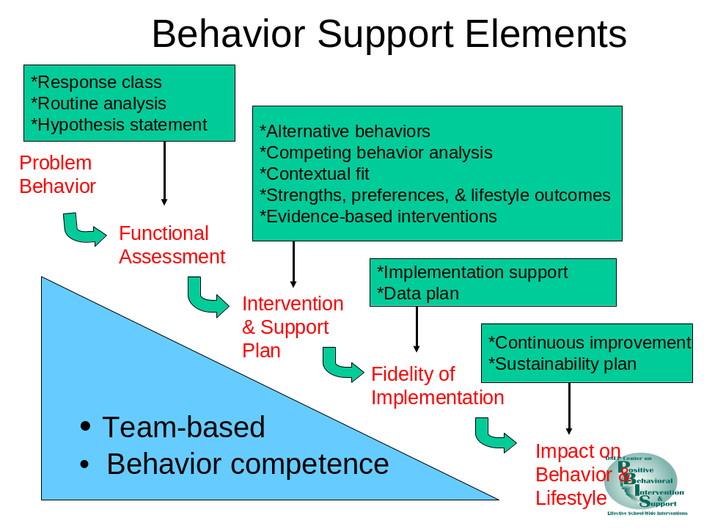

Problem Behaviors and Functions
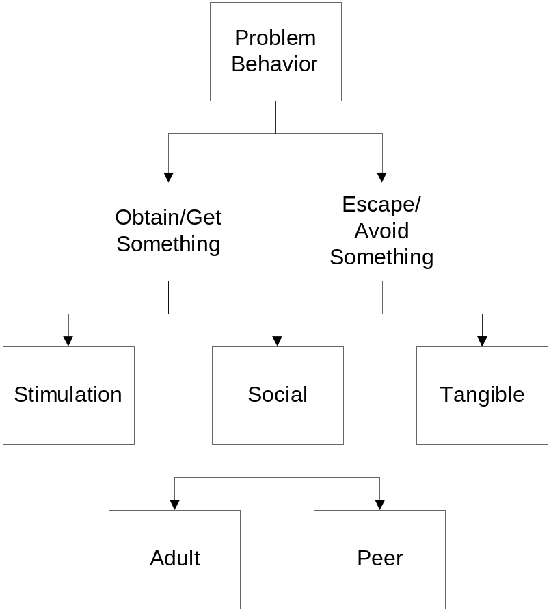

What are the essential steps of the FBA process?

- Collect data to determine function of problem behavior  - Develop testable hypotheses or summary statements and indicate possible function  - Collect direct observation data to confirm summary statement  - Identify desired and acceptable replacement behaviors based on summary statement and behavior function  - Develop behavior intervention plan based on summary statement and behavior function  - Develop details & routines to ensure high fidelity implementation of behavior intervention plan  - Develop strategies for on-going monitoring & evaluation | 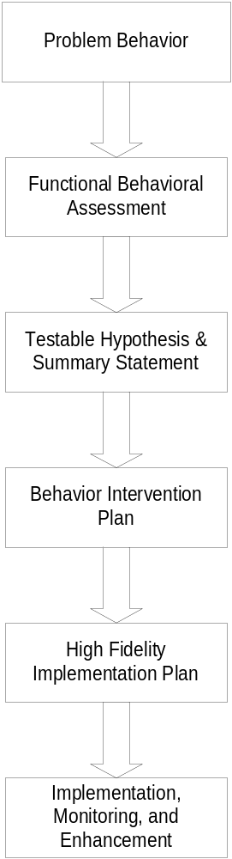

Behavior Support Planning Process

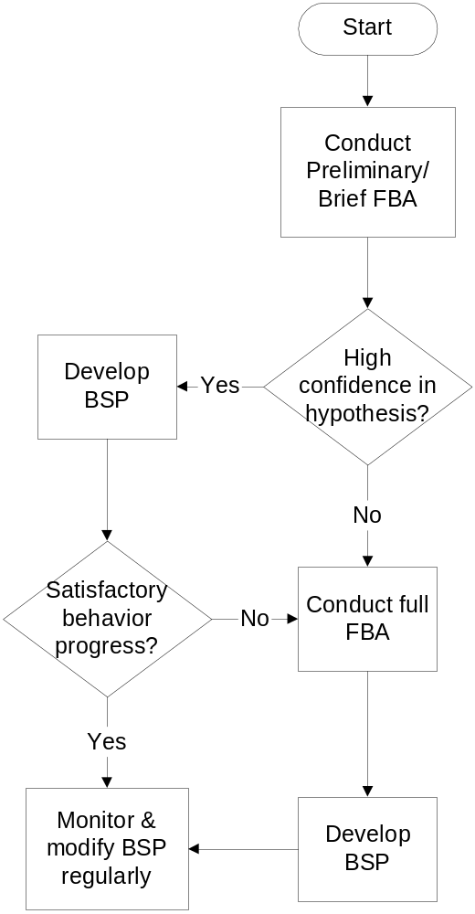

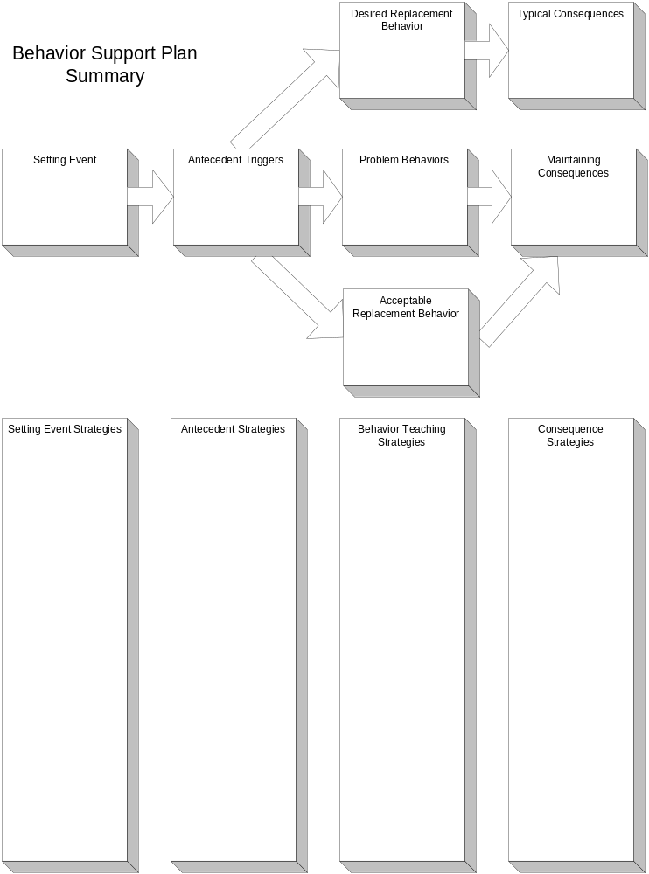

Checklist for Assessing Quality of Behavior Support Planning:
Does Plan and Process Have These Features?

1. ____ Definition of academic and lifestyle context for behavior support
- ____ Operational/observable/measurable description of problem behaviors
3. ____ Identification of problem routines
4. ____ Statements of hypotheses based on functional assessment information
- Descriptions of Interventions & Supports that Consider Quality of Life
____ Health and physiology
____ Communication
____ Mobility
____ Predictability
____ Control/choice
____ Social relationships
____ Activity patterns
- Descriptions of Preventive Interventions that Make Problem Behavior Irrelevant
____ Physical environment
____ Schedule
____ Curriculum
____ Instructional procedures
- Descriptions of Instructional & Teaching Interventions that Make Problem Behavior Inefficient
____ Replacement skills
____ New adaptive skills
- Descriptions of Consequence-based Interventions that Reduce Likelihood of Problem Behavior
____ Minimization of positive reinforcement to make problem behavior ineffective (extinction)
____ Minimization of negative reinforcement to make problem behavior ineffective (extinction)
____ Maximization of positive reinforcement to make appropriate behavior more effective (reinforcement)
____ If needed, aversive consequences contingent upon problem behavior (punishment)
____ Safety/emergency intervention plan for occurrences of severe problem behaviors
- Descriptions of Evaluation & Assessment Procedures
____ Definition of information to be collected
____ Description of measurement process
____ Description of decision-making process
- Descriptions of Procedures to Consider & Enhance Contextual Fit
____ Values & beliefs of participants
____ Skill capacity & fluency of implementers
____ Availability of supporting resources
____ Administrative support system
____ Plan in best interest of student
Functional Assessment Checklist for Teachers and Staff (FACTS-Part A)

Student/ Grade: ______________________________ Date: ____________________________
Interviewer: _________________________________ Respondent(s): ____________________

Student Profile: Please identify at least three strengths or contributions the student brings to school.
___________________________________________________________________________________
___________________________________________________________________________________

Problem Behavior(s): Identify problem behaviors

___ Tardy | ___ Fight/physical aggression |  | ___ Disruptive | ___ Theft
___ unresponsive | ___ Inappropriate Language |  | ___ Insubordination | ___ Vandalism
___ Withdrawn | ___ Verbal Harassment |  | ___ Work not done | ___ Other ________________
 | ___ Verbally Inappropriate |  | ___ Self-injury
Describe problem behavior:

Identifying Routines: Where, When and With Whom Problem Behaviors are Most Likely.

Schedule (Times) | Activity | Likelihood of Problem Behavior | Specific Problem Behavior
Low High
1 2 3 4 5 6
 |  | 1 2 3 4 5 6
 |  | 1 2 3 4 5 6
 |  | 1 2 3 4 5 6
 |  | 1 2 3 4 5 6
 |  | 1 2 3 4 5 6
 |  | 1 2 3 4 5 6
 |  | 1 2 3 4 5 6
 |  | 1 2 3 4 5 6
 |  | 1 2 3 4 5 6
 |  | 1 2 3 4 5 6

Select 1-3 Routines for further assessment: Select routines based on (a) similarity of activities (conditions) with ratings of 4, 5 or 6 and (b) similarity of problem behavior(s). Complete the FACTS-Part B for each routine identified.

Functional Assessment Checklist for Teachers & Staff (FACTS-Part B)

Student/ Grade: ______________________________ Date: ____________________________
Interviewer: _________________________________ Respondent(s): ____________________

Routine/Activities/Context: Which routine(only one) from the FACTS-Part A is assessed?
Routine/Activities/Context | Problem Behavior(s)

Provide more detail about the problem behavior(s):
What does the problem behavior(s) look like?

How often does the problem behavior(s) occur?

How long does the problem behavior(s) last when it does occur?

What is the intensity/level of danger of the problem behavior(s)?

What are the events that predict when the problem behavior(s) will occur? (Predictors)
Related Issues (setting events) | Environmental Features
___ illness Other:_________________  ___ drug use ______________________  ___ negative social ______________________  ___ conflict at home ______________________  ___ academic failure ______________________ | ___ reprimand/correction ___ structured activity  ___ physical demands ___ unstructured time  ___ socially isolated ___ tasks too boring  ___ with peers ___ activity too long  ___ Other ___ tasks too difficult  __________________

What consequences appear most likely to maintain the problem behavior(s)?
Things that are Obtained | Things Avoided or Escaped From
___ adult attention Other: ________________  ___ peer attention ______________________  ___ preferred activity ______________________  ___ money/things ______________________ | ___ hard tasks Other: ___________________  ___ reprimands ________________________  ___ peer negatives ________________________  ___ physical effort ________________________  ___ adult attention ________________________

SUMMARY OF BEHAVIOR
Identify the summary that will be used to build a plan of behavior support.
Setting Events & Predictors | Problem Behavior(s) | Maintaining Consequence(s)

How confident are you that the Summary of Behavior is accurate?

Not very confident Very Confident
1 2 3 4 5 6

What current efforts have been used to control the problem behavior?
Strategies for preventing problem behavior | Strategies for responding to problem behavior
___ schedule change Other: ________________  ___ seating change ______________________  ___ curriculum change ______________________ | ___ reprimand Other: ___________________  ___ office referral _________________________  ___ detention _________________________

March, Horner, Lewis-Palmer, Brown , Crone, Todd, & Carr (2000) 4/24/00

OSEP Center on Positive Behavioral Interventions and Supports. Go to www.pbis.org or contact George Sugai (george.sugai@uconn.edu) for additional information.
To calculate, divide # positives by # of negatives.
Draft 3-10-04 Sugai
To calculate, divide # positives by # of negatives.
Yes ? No
Eliminate, Modify, Integrate, Sustain
3-10-04. Adapted from Sugai, G., Lewis-Palmer, T., & Hagan-Burke, S. (1999-2000). Overview of the functional behavioral assessment process. Exceptionality, 8, 149-160.
3-10-04 Adapted from Horner, R., Sugai, G., Todd, A., & Lewis-Palmer, T. (1999-2000). Elements of behavior support plans. Exceptionality, 8(3), 205-216

