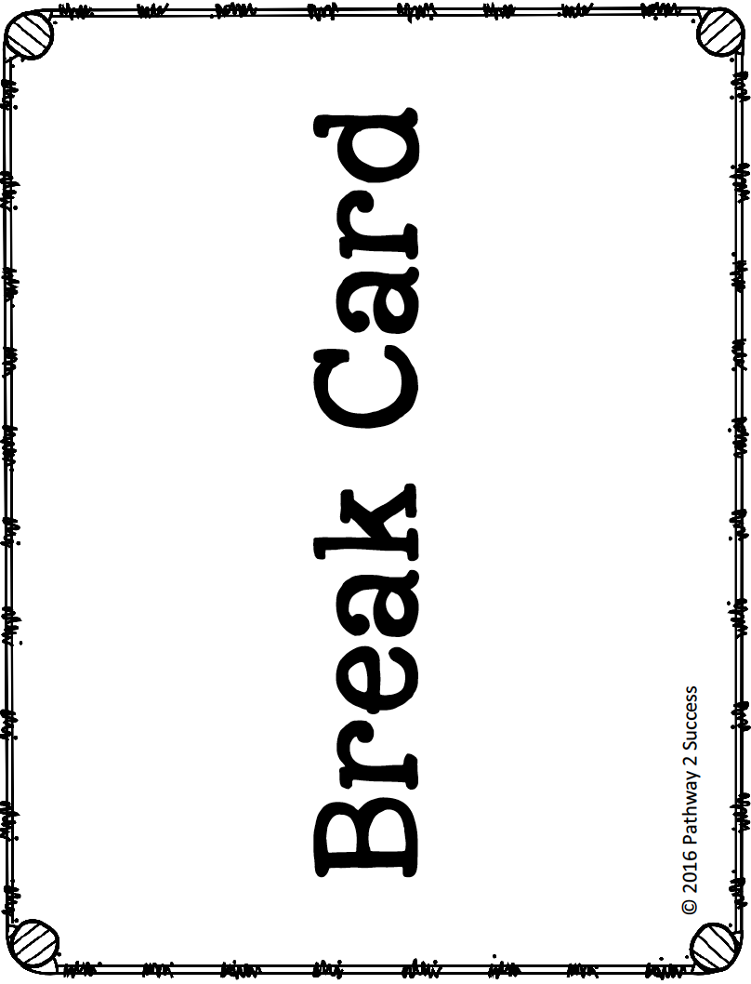



I would like to take a

5 10 15 minute

break to:

__________________________

Time Left: ____ : ____

Time to Return: ____ : ____

Teacher Signature: ______________________

I would like to take a

5 10 15 minute

break to:

__________________________

Time Left: ____ : ____

Time to Return: ____ : ____

Teacher Signature: ______________________

